Community Notes, CUNY & the Bronx County Historical Society Archives, Vani Kannan & Steven Payne

Proof: Round 1

Part 1: Changes located by JBW editors

Directions for authors: Please review the list below of minor formatting or stylistic issues that arose when the editorial team re-read your manuscript. We will make these changes before the next round of proofreading. If any items involve a substantive editorial change or a question for the author, they will be highlighted in yellow; please leave a comment replying to those items, indicating whether you accept or reject the change and/or offering alternate phrasing if needed. Any other items below do not require a response unless you disagree with the change.

- need abstract and keywords; p. 94 still has “ABSTRACT. [ABSTRACT TK]” and “KEYWORDS: [KEYWORDS TK]”
- need author bios; p. 95 still has two template bios
- confirm with authors that title/running-head should use ampersand instead of “and”: p. 94 “CUNY & the Bronx County...”
- p. 94, five lines from start of article: consider removing “--including Vani–” as the phrase feels out of place in the sentence and at this early point in the article
- p. 96, 9 lines from bottom: replace “who” with “whom”
- p. 96, 7 lines from bottom, please re-read and revise/condense this sentence for clarity: “The majority of Vani’s students lived in the Bronx, and in this context, teaching with social movement archives aimed to push back against ahistorical racist, classist renderings of the borough that erase both grassroots social justice movements and the redlining and disinvestment that shaped its geography.”
- p. 100, 2nd paragraph, 10 lines down: paragraph break needed starting with the words “On the other hand, actualizing…” as per the original manuscript
- p. 100, 13 lines from the bottom: please consider revising the following long sentence for clarity and succinctness: “For example, the history of Bronx health justice movements focus that revolutionary groups like the Young Lords had on healthcare was certainly crucial at the time [should this read, “the Young Lords’ focus on Bronx health justice movements…”?]; with the mushrooming of the medical industrial complex in the U.S. in the five decades since, the nurses’ strikes at nearby Montefiore Hospital, and ongoing campaigns around reproductive justice and safe/healthy housing, though, this focus now appears absolutely prescient and as one of the most vital contributions of that era of struggle—and offers a particularly salient focus for Lehman’s many students who will go into health professions in local hospitals.”
- regularize p. 102 Augustine date: “5 February 2026”
- p. 102, Note 1: Does this need to be a note or should it be in the body of the text? Is this information necessary to a reader's understanding of how Steven and Vani met? (In other words, do readers need to know that Vani overheard this conversation?) Vani and Steven met at the green space event and that's how they became collaborators, or are we misunderstanding?
- add missing web-entry metadata or n.d. on p. 103 where needed
- We want to suggest that you condense Figure 1 and Figure 2 captions to include only the first sentences (depicted below). We invite the authors to reference the figures in the body of the text, rather than build their contextualization into the caption itself. Please let us know if you accept this change and what changes are needed in the body text, if any.
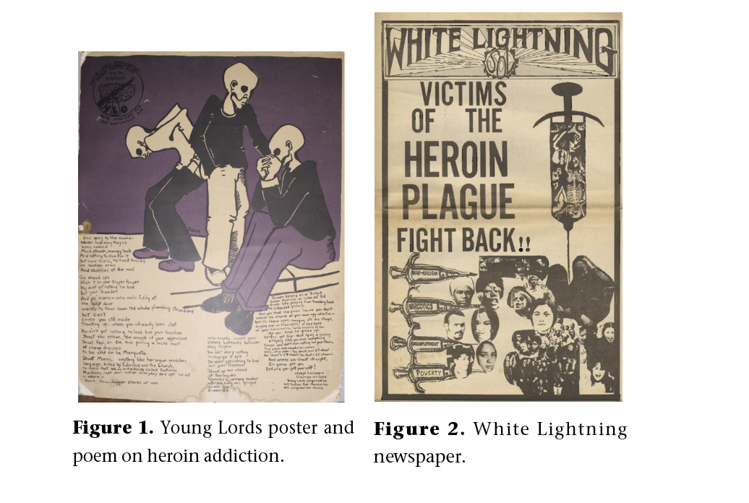
Part 2: Changes requested by author

Directions for authors: Please re-read your article carefully and add any additional minor changes you would like us to make below. We cannot make significant revisions to content at the proofreading stage; please limit your request to missing words, punctuation, spelling, citation errors and other minor edits.
Please list your requested changes following the format below. Aim for a clear and simple message that conveys what you want to CHANGE, REMOVE, or ADD. For each change, note the page, where in the page (middle, top, lines from top), your direction, e.g. Place new text in bold.

Sample Formatting:
- Page 3, 17 lines from bottom, change "original passage" to "new text"
OR
- "17 lines from top, "original passage" should read "new text"

